https://www.google.com/url?sa=i&url=https%3A%2F%2Fstylowi.pl%2F25562804&psig=AOvVaw2li1bT3KJSBrcecVCDjzJ7&ust=1606477437114000&source=images&cd=vfe&ved=0CAIQjRxqFwoTCNjqgvqQoO0CFQAAAAAdAAAAABAZ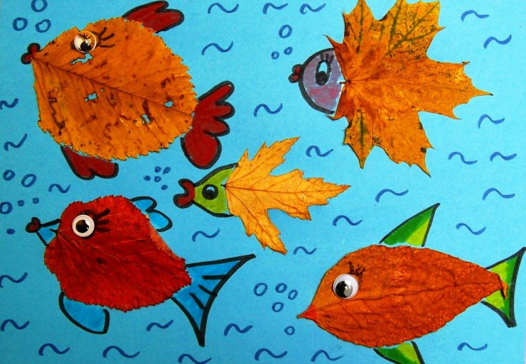

http://rozwinskrzydla.info/wp-content/uploads/2010/09/dsc03231.jpg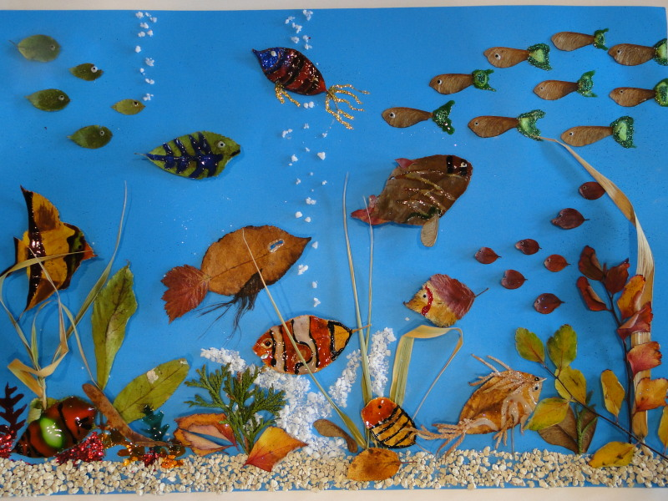

https://encrypted-tbn0.gstatic.com/images?q=tbn:ANd9GcQ0t0v6XpeJn-z38MWnxCzyJvqg64Y18-iuKw&usqp=CAU
